Inventory Management System using Excel VBA

ABSTRACT
This project, titled “Inventory Management System using Excel VBA”, is developed to provide an efficient and automated solution for managing inventory in small and medium-scale organizations. The primary purpose of this project is to simplify the process of tracking products, managing stock levels, and generating meaningful inventory reports without the need for complex database systems.
The system allows users to add and manage product details, perform stock-in and stock-out operations, monitor current stock levels, and identify low-stock products based on predefined reorder levels. Additionally, the project includes an interactive dashboard that visually represents inventory data using charts, enabling quick decision-making.
The project is developed using Microsoft Excel as the front-end interface and Visual Basic for Applications (VBA) for automation and business logic implementation. Excel macros are used to handle data processing, validations, calculations, and chart generation. By combining Excel’s data handling capabilities with VBA automation, the system provides a user-friendly, cost-effective, and flexible inventory management solution suitable for educational and practical business use.

INTRODUCTION
What is Inventory Management
Inventory management is the process of ordering, storing, tracking, and controlling goods and materials used or sold by an organization. It involves maintaining optimal stock levels to ensure that products are available when needed while minimizing excess inventory and storage costs. Effective inventory management helps businesses maintain smooth operations and avoid shortages or overstocking.

Why Inventory Management is Important
Inventory management plays a crucial role in the success of any business. Proper inventory control:
- Ensures continuous availability of products
- Reduces wastage and storage costs
- Helps in accurate demand forecasting
- Improves customer satisfaction
- Supports better financial planning and decision-making
An efficient inventory system allows businesses to respond quickly to changes in demand and maintain a competitive advantage.

Problems with Manual Inventory Tracking
Manual inventory tracking using registers or basic spreadsheets often leads to several issues, such as:
- Data entry errors
- Difficulty in tracking real-time stock levels
- Time-consuming calculations
- Lack of proper reporting and analysis
- No alerts for low stock levels
- Poor visibility into inventory performance
These limitations make manual systems inefficient, especially as the volume of inventory increases.

What the System Does
The Excel VBA-based Inventory Management System addresses the limitations of manual tracking by automating inventory operations. The system enables users to:
- Maintain a centralized product master
- Perform stock-in and stock-out operations with validation
- Automatically update current stock levels
- Identify low-stock products
- Generate inventory summaries
- Visualize inventory data using dynamic charts and dashboards
This automated approach improves accuracy, efficiency, and visibility while remaining simple and cost-effective.

OBJECTIVES OF THE PROJECT
The main objectives of the Inventory Management System using Excel VBA are as follows:
- To automate the process of inventory tracking and management using Excel and VBA.
- To maintain a centralized product master containing product details such as product ID, name, category, price, reorder level, and current stock.
- To manage stock-in and stock-out operations efficiently with proper validations.
- To reduce manual data entry errors by implementing automated calculations and checks.
- To generate low stock alerts based on predefined reorder levels.
- To provide real-time visibility of inventory levels.
- To generate inventory summaries such as total stock value and total quantity.
- To visualize inventory data using interactive dashboards and charts.
- To create a user-friendly system suitable for small and medium-scale businesses.
- To enhance decision-making through accurate and organized inventory reports.

SCOPE OF THE PROJECT
Included Features
The scope of this project includes the following features:
- Addition and management of product details through Excel sheets and user forms.
- Automated stock-in and stock-out transactions with validation checks.
- Real-time updating of current stock levels.
- Automatic calculation of inventory metrics such as:
  - Total stock value
  - Total quantity by category
  - Product count
  - Low stock count
- Generation of low stock reports.
- Creation of a dynamic dashboard with bar charts for visual analysis.
- Importing inventory data using CSV files.
- Basic sheet protection to prevent accidental modification of summary and dashboard sheets.
Excluded Features
The following features are outside the scope of this project:
- Multi-user access and concurrency control.
- Integration with external databases (SQL, MySQL, etc.).
- Online or cloud-based access.
- Barcode or RFID integration.
- Automatic purchase order generation.
- Email or SMS alerts for low stock.
Limitations of the Project
- The system is designed for single-user operation.
- Performance may be affected for very large datasets due to Excel limitations.
- Security is limited to basic sheet protection.
- The system depends on Microsoft Excel and cannot function independently.
- Advanced analytics and forecasting are not included.

SOFTWARE & HARDWARE REQUIREMENTS
Software Requirements
The following software components are required to develop and run the Inventory Management System:
- Microsoft Excel (2016 or later)
Used as the primary interface for data storage, processing, and visualization.
- Visual Basic for Applications (VBA)
Used to automate inventory operations, validations, calculations, and dashboard generation.
- Excel Macros Enabled (.xlsm format)
Required to execute VBA code and macros.
- Windows Operating System
The system is designed and tested on Windows-based platforms.

Hardware Requirements
The minimum hardware requirements to run the system efficiently are:
- Processor: Standard Intel/AMD processor
- RAM: Minimum 4 GB
- Storage: At least 500 MB free disk space
- Device: Desktop computer or Laptop
- Input Devices: Keyboard and Mouse

MODULES DESCRIPTION
The Inventory Management System is divided into multiple functional modules. Each module is designed to perform specific operations related to inventory control and reporting.
1. Import CSV Data Module
The Import CSV Data Module allows bulk insertion of product data into the system using a CSV file. This feature helps eliminate manual data entry and enables faster initialization of inventory records.
Functions:
- Allows the user to select a CSV file using a file selection dialog.
- Imports product data directly into the Product Master sheet.
- Supports structured datasets containing product ID, name, category, price, reorder level, and current stock.
- Prevents accidental shifting of existing worksheet layout.
- Ensures seamless integration of external data into the inventory system.
This module improves efficiency, reduces human error, and supports scalability by allowing large datasets to be imported at once.

2. Product Master Module
The Product Master Module is used to maintain detailed information about all products in the inventory. This module acts as the core data repository of the system.
Functions:
- Add new products to the inventory.
- Store essential product details such as:
  - Product ID
  - Product Name
  - Category
  - Unit Price
  - Reorder Level
  - Current Stock
- Prevent duplicate product entries.
- Ensure consistent categorization of products.
This module ensures accurate and structured storage of inventory data.
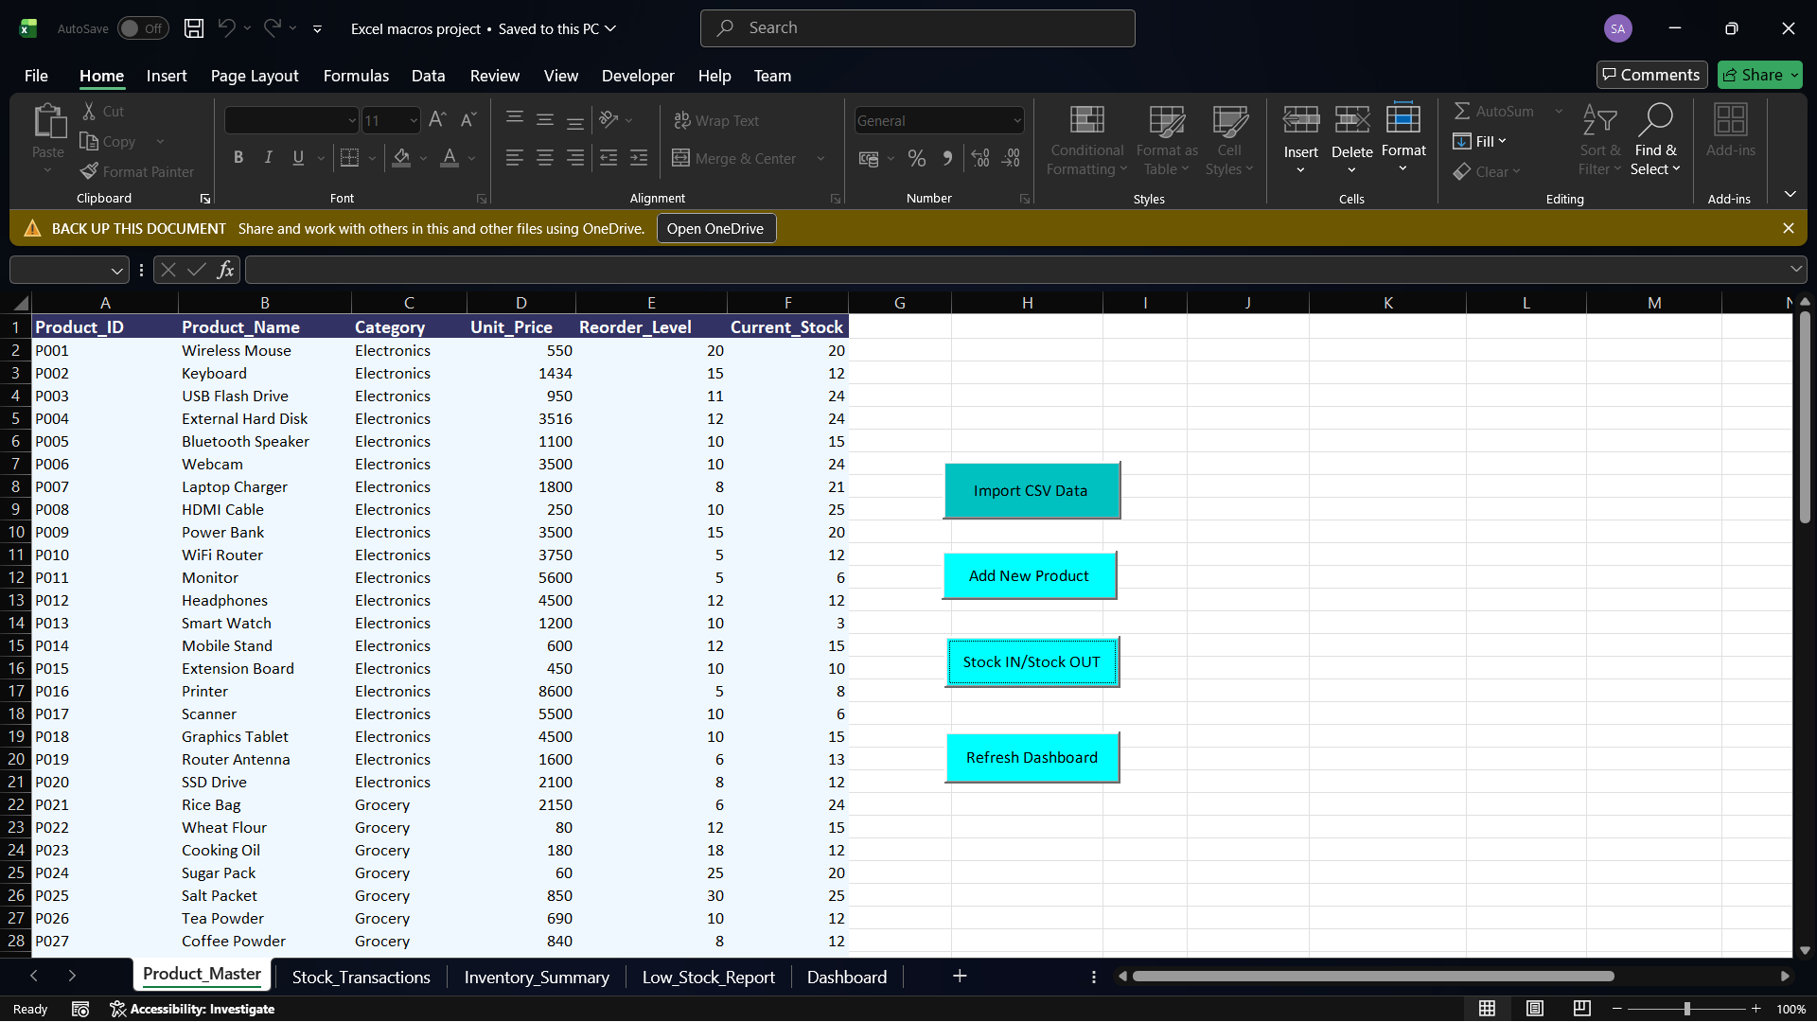
Figure 1: Product Master sheet containing inventory data

3. Stock In / Stock Out Module
The Stock In / Stock Out Module manages inventory movement and updates stock levels dynamically.
Functions:
- Increase stock quantity when new inventory is received (Stock IN).
- Decrease stock quantity when products are sold or issued (Stock OUT).
- Perform validation checks such as:
  - Product existence verification
  - Quantity validation
  - Insufficient stock prevention
- Automatically update current stock levels.
- Record stock transactions for tracking purposes.
This module ensures accurate inventory movement tracking and prevents stock inconsistencies.
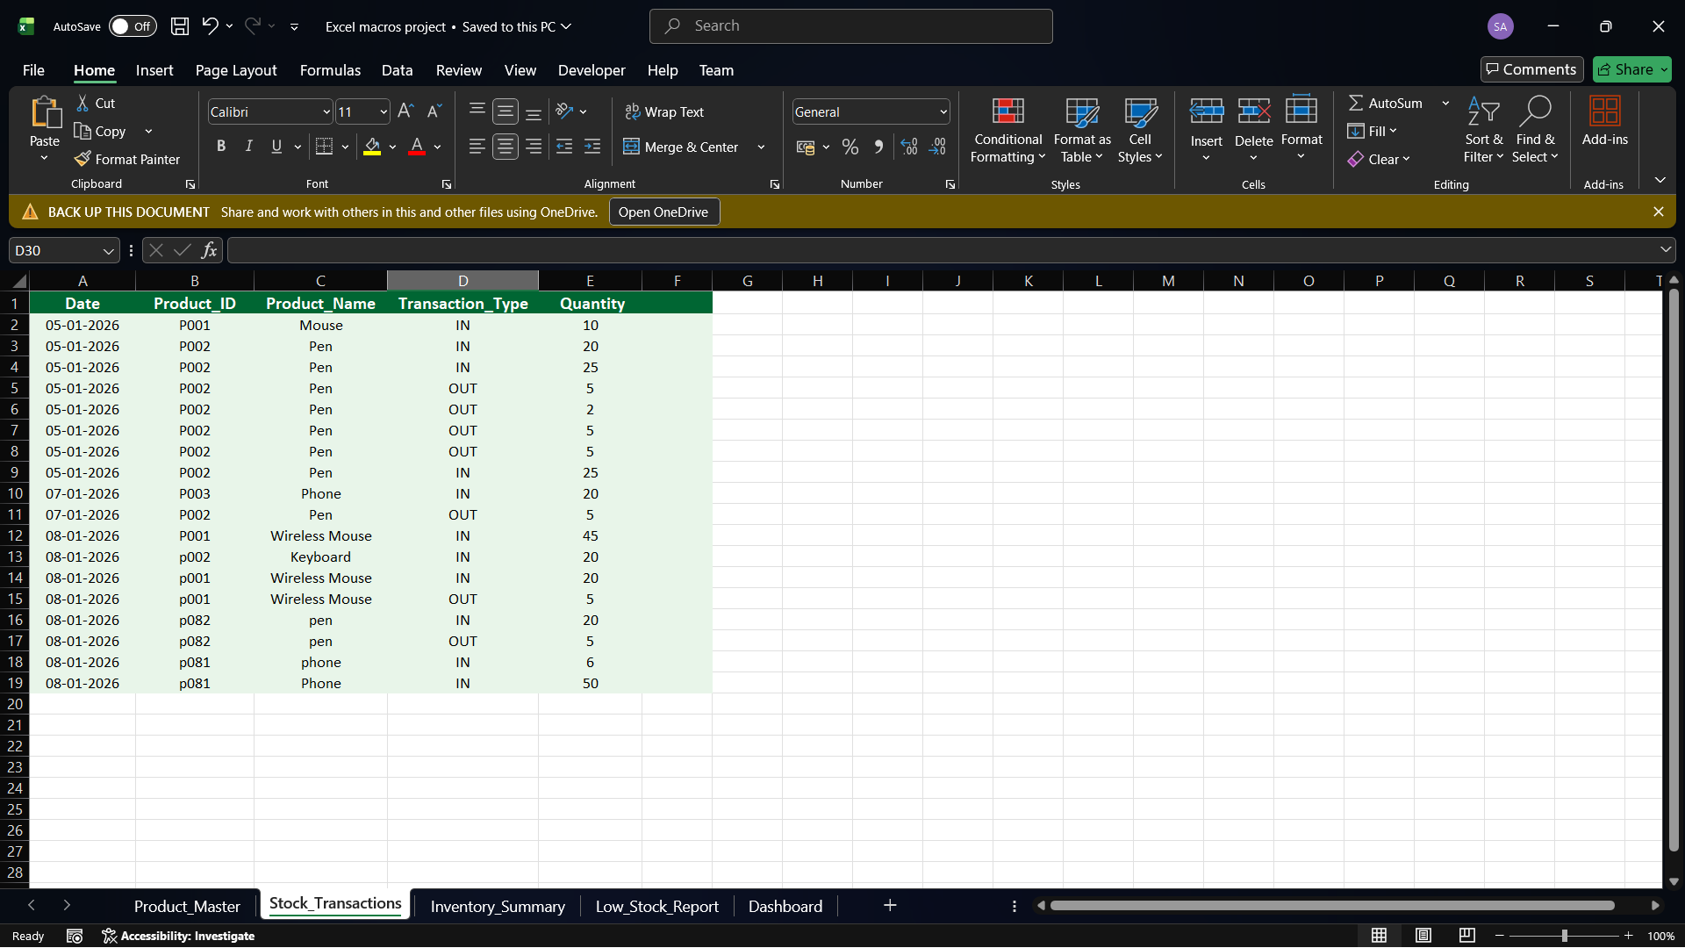
Figure 2: Stock Transactions sheet recording inventory movements

4. Inventory Summary Module
The Inventory Summary Module provides a consolidated view of inventory information for analysis and decision-making.
Functions:
- Calculate category-wise inventory totals.
- Compute total stock quantity.
- Calculate total stock value using unit price and current stock.
- Provide summarized data for dashboard visualization.
This module helps management quickly understand inventory status at a glance.
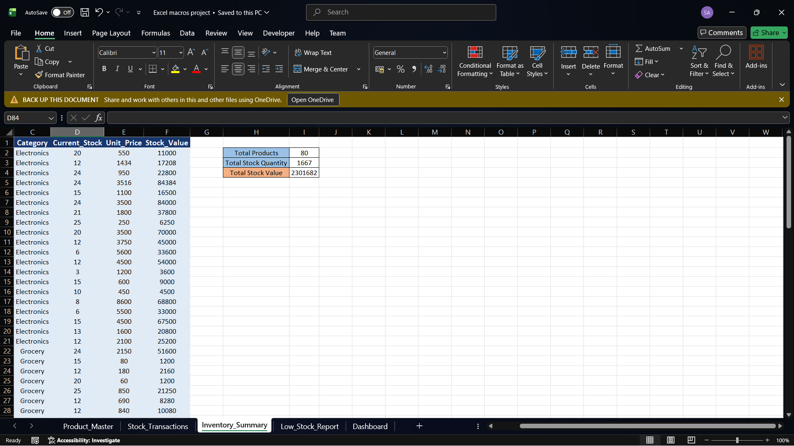
Figure 3: Inventory Summary sheet showing category-wise totals
5. Low Stock Report Module
The Low Stock Report Module identifies products that require replenishment.
Functions:
- Compare current stock levels with reorder levels.
- Identify products with stock below or equal to the reorder level.
- Generate a structured low stock report.
- Assist in timely procurement planning.
This module helps avoid stock shortages and ensures uninterrupted business operations.
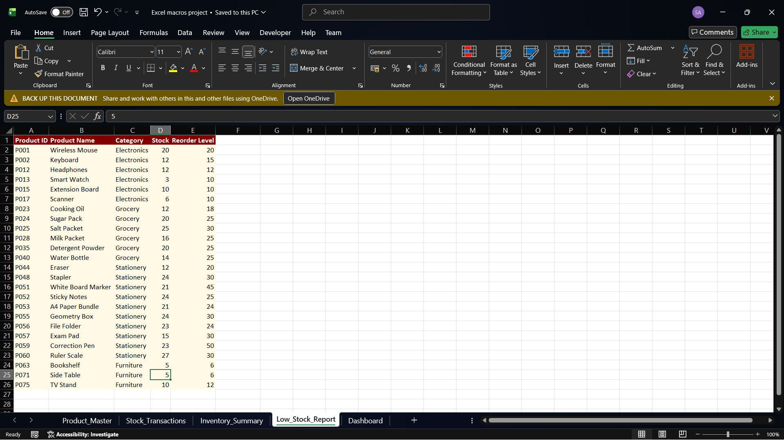
Figure 4: Low Stock Report identifying products below reorder level
6. Dashboard Module
The Dashboard Module visually represents inventory data in an interactive and user-friendly format.
Features:
- Bar charts displaying:
  - Total stock value by category
  - Total stock quantity by category
  - Number of products by category
  - Low stock product count by category
- Dynamic updates based on inventory changes.
- Easy interpretation of inventory trends.
This module enhances data visualization and supports informed decision-making.
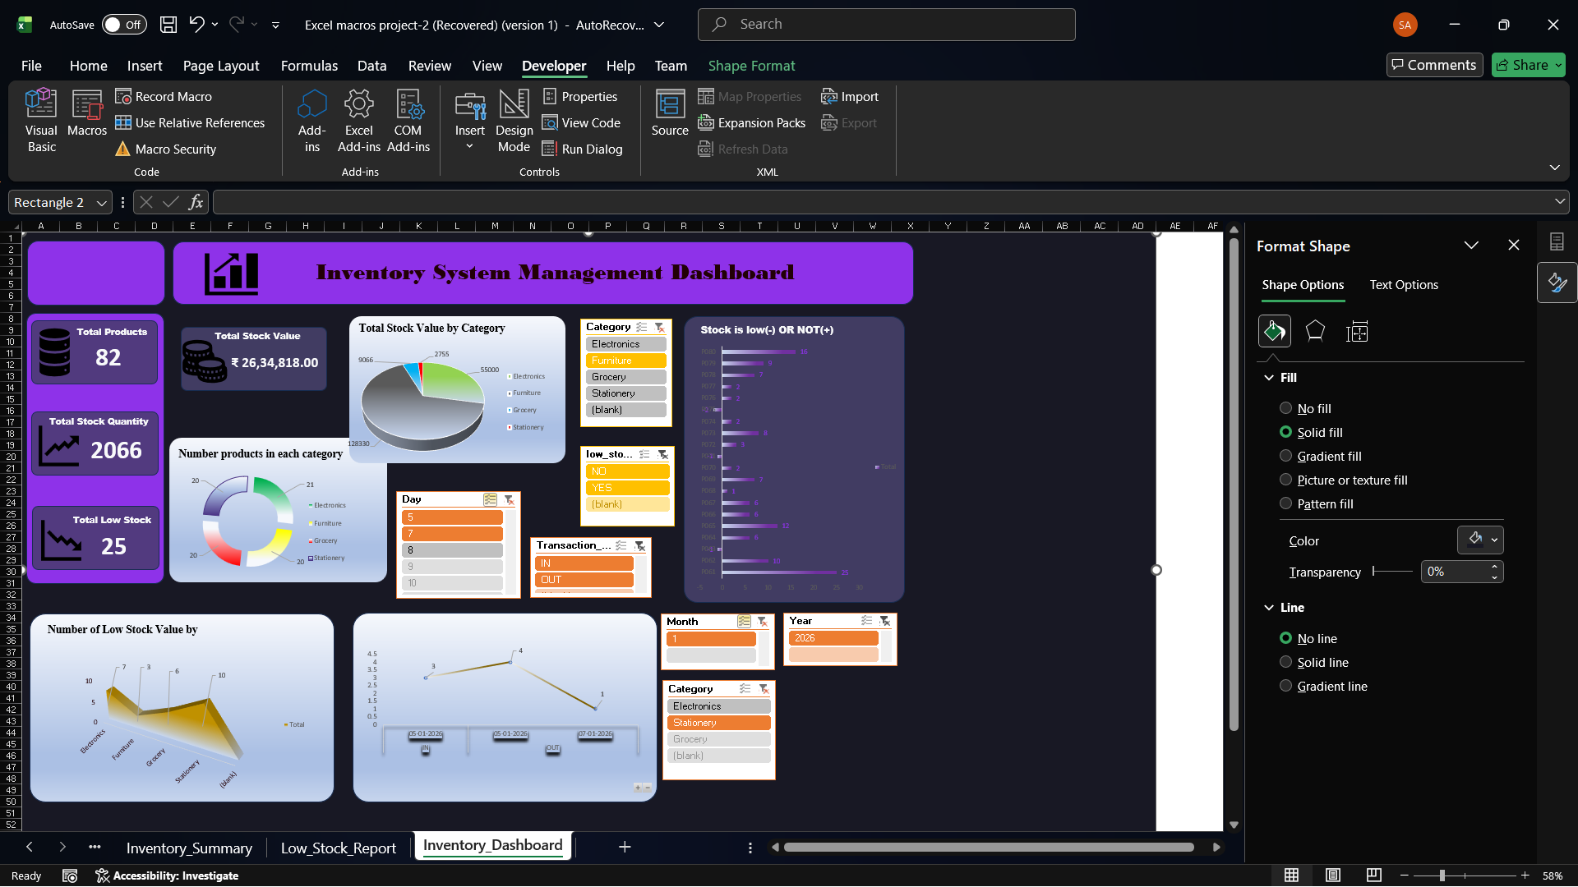
Figure 5: Inventory Dashboard displaying graphical summary

DATASET DESCRIPTION
The dataset used in this project represents inventory information for various products across multiple categories. The dataset was designed to simulate a real-world inventory environment and is suitable for testing and demonstrating inventory operations.

Source of Dataset
- The dataset was created manually and imported using a CSV file.
- The CSV file was imported into Excel to populate the Product Master sheet.
- This approach ensures flexibility and allows bulk data loading without manual data entry.
Fields Used in the Dataset
The dataset contains the following fields:
- Product ID:
A unique identifier assigned to each product.
- Product Name:
Descriptive name of the product.
- Category:
Classification of products into categories such as Electronics, Grocery, Stationery, and Furniture.
- Price:
Unit price of each product.
- Reorder Level:
Minimum stock level at which replenishment is required.
- Current Stock:
Available quantity of each product in inventory.
Number of Records
- The dataset consists of 100 product records.
- This volume of data ensures effective testing of inventory operations, reports, and dashboard visualizations.
USER INTERFACE DESCRIPTION
The user interface of the Inventory Management System is designed to be simple, interactive, and user-friendly. It utilizes Excel UserForms and command buttons to perform inventory operations efficiently.
UserForms Used
- Import CSV Data Form:
The Import CSV Data form provides a simple interface for loading external inventory data into the system. It includes a command button that opens a file dialog for selecting a CSV file. Once selected, the data is imported automatically into the Product Master sheet.
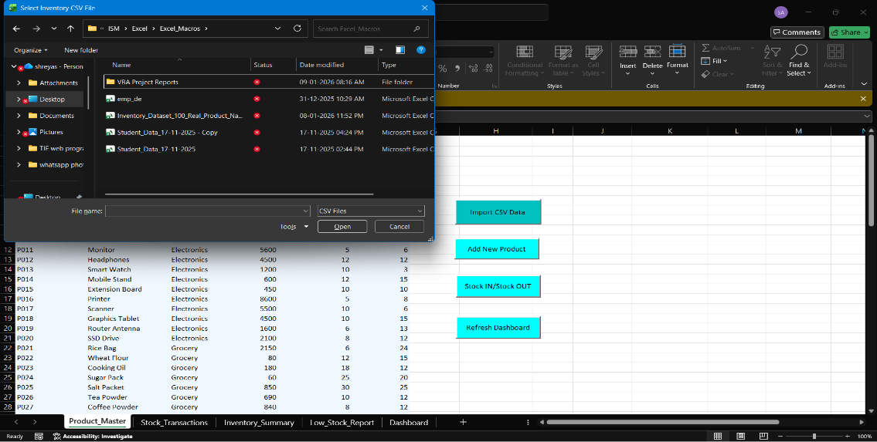
Figure 6: Import CSV Data UserForm for bulk product data loading

- Product Entry UserForm:
Used to add and manage product details such as product ID, name, category, price, reorder level, and initial stock.
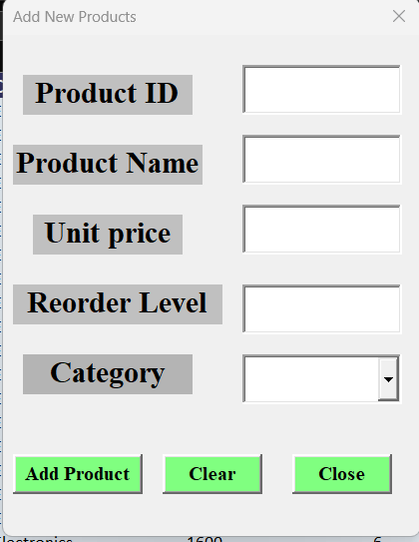
Figure 7: Product Entry UserForm for adding product details
- Stock Transaction UserForm:
Used to perform stock-in and stock-out operations by selecting a product and entering the transaction quantity.
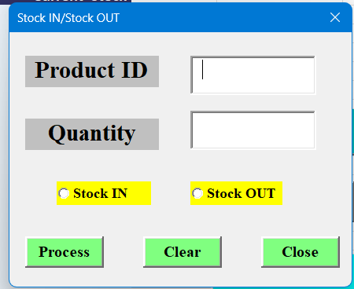
Figure 8: Stock IN / Stock OUT UserForm for inventory transactions

Buttons and Their Functionality
The system includes various command buttons to perform specific actions:
- Add Product: Adds a new product to the Product Master sheet.
- Stock IN: Increases the current stock of the selected product.
- Stock OUT: Decreases the current stock of the selected product.
- Clear: Clears all input fields in the user form.
- Close: Closes the user form.
- Refresh Dashboard: Updates summary data and refreshes dashboard charts.
Input Fields and Validations
The system implements multiple validations to ensure data accuracy:
- Mandatory field validation to prevent empty inputs.
- Duplicate Product ID validation to avoid redundant entries.
- Numeric validation for price, quantity, and stock fields.
- Insufficient stock validation during stock-out operations.
- Category selection validation using predefined lists.
These validations ensure reliable and error-free inventory management.

VBA CONCEPTS USED
The Inventory Management System extensively uses various VBA concepts to automate inventory operations and enhance functionality. These concepts play a crucial role in ensuring efficiency, accuracy, and user interaction.

UserForms
UserForms are used to create an interactive interface for user input. They allow users to add products, perform stock-in and stock-out operations, and interact with the system without directly modifying Excel sheets.

Modules
Standard VBA modules are used to store reusable procedures and functions. Modules help organize code logically and improve maintainability.

Procedures & Functions
- Sub procedures are used to perform specific tasks such as adding products, updating stock, generating reports, and creating charts.
- Helper procedures are used to avoid code repetition and improve readability.

Loops
- For loops are used to iterate through rows in worksheets for calculations and data aggregation.
- For Each loops are used to loop through collections such as chart objects and worksheet ranges.

Conditional Statements
- If…Then…Else statements are used for validations and decision-making, such as checking stock levels.
- Select Case statements are used for category-based calculations and logic implementation.

Worksheet Events
Worksheet events such as Worksheet_Change are used to trigger automatic actions when data changes, ensuring real-time updates.

ChartObjects
The ChartObject class is used to dynamically create and update charts on the dashboard. This allows visualization of inventory data through bar charts.

Error Handling
Basic error-handling techniques are implemented using:
- Conditional checks
- Message boxes for user-friendly error messages
- Controlled execution flow to prevent unexpected crashes

VALIDATION & ERROR HANDLING
Validation and error handling are critical components of the system to ensure data accuracy and reliability.
Empty Field Validation
- Mandatory fields are validated to prevent blank inputs.
- The system prompts the user if any required field is left empty.

Duplicate Product ID Check
- Before adding a new product, the system checks whether the Product ID already exists.
- This prevents duplicate records and maintains data integrity.

Insufficient Stock Check
- During stock-out operations, the system verifies whether sufficient stock is available.
- If the requested quantity exceeds current stock, the operation is blocked with an error message.

Category Validation
- Categories are validated using predefined lists to ensure consistency.
- This prevents incorrect or inconsistent category entries that could affect reports and dashboards.

DASHBOARD & CHARTS EXPLANATION
The Dashboard module provides a visual summary of inventory data using charts. It helps users quickly analyze inventory performance and make informed decisions. The dashboard is dynamically updated based on changes in inventory data.

Figure 5: Inventory Dashboard displaying graphical summary

Chart 1: Total Stock Value by Category
- Chart Type: Bar Chart (Column Chart)
- Data Source: DashboardData sheet (Category vs Total Stock Value)
- Purpose:
This chart displays the total monetary value of inventory available in each category. It helps management understand which category holds the highest investment.
- Reason for Choosing Bar Chart:
Bar charts are effective for comparing numeric values across categories, making it easy to identify high and low stock value categories.

Chart 2: Total Stock Quantity by Category
- Chart Type: Bar Chart (Column Chart)
- Data Source: DashboardData sheet (Category vs Total Quantity)
- Purpose:
This chart shows the total number of items available in each category, helping monitor stock distribution.
- Reason for Choosing Bar Chart:
Bar charts clearly show differences in quantities between categories and support quick comparison.

Chart 3: Number of Products by Category
- Chart Type: Bar Chart (Column Chart)
- Data Source: DashboardData sheet (Category vs Product Count)
- Purpose:
This chart represents how many distinct products are available in each category, helping assess product diversity.
- Reason for Choosing Bar Chart:
Bar charts effectively represent discrete counts across multiple categories.

Chart 4: Low Stock Products by Category
- Chart Type: Bar Chart (Column Chart)
- Data Source: DashboardData sheet (Category vs Low Stock Count)
- Purpose:
This chart identifies categories with a higher number of low-stock products, supporting proactive replenishment planning.
- Reason for Choosing Bar Chart:
Bar charts provide a clear visual comparison of alert-level data across categories.
Overall Dashboard Benefit
The dashboard provides a consolidated and visual overview of inventory metrics, reducing the need to analyze raw data manually.
Limitations of the Project
Despite providing an effective solution for basic inventory management, the system has certain limitations:
- The system supports single-user operation only and does not handle multiple users simultaneously.
- There is no database connectivity; all data is stored within Excel sheets.
- Performance may degrade with very large datasets due to Excel file size and row limitations.
- Security is limited to basic Excel sheet protection.
- The system is dependent on Microsoft Excel and cannot operate as a standalone application.
- Advanced analytics and demand forecasting features are not included.
- The system does not support real-time cloud-based access.
Future Enhancements
The following enhancements can be implemented in the future to improve system functionality and scalability:
- Integration with a database system such as SQL Server or MySQL for improved data handling and performance.
- Support for barcode scanners to enable faster and more accurate inventory updates.
- Implementation of email or SMS alerts for low stock notifications.
- Introduction of role-based access control (Admin, Manager, User).
- Development of a web-based or cloud-enabled version of the system.
- Integration with purchase and sales modules.
- Advanced reporting and data analytics features.
CONCLUSION
The Inventory Management System using Excel VBA successfully achieves its objective of automating inventory tracking and control in a simple and efficient manner. The system provides a structured approach to managing product details, monitoring stock levels, performing stock-in and stock-out operations, and identifying low-stock items.
By integrating Excel with VBA automation, the project eliminates many of the challenges associated with manual inventory management, such as data inconsistency, calculation errors, and lack of real-time visibility. The inclusion of a dynamic dashboard with visual charts further enhances decision-making by presenting inventory insights in an easy-to-understand format.
This system is particularly beneficial for small and medium-sized businesses that require an affordable and user-friendly inventory solution without the complexity of full-scale enterprise systems. The project also serves as a practical example of how Excel VBA can be effectively used to develop real-world business applications.
Through this project, valuable learning outcomes were achieved, including hands-on experience with VBA programming, user form design, data validation, report generation, and dashboard creation. Overall, the project demonstrates the practical application of Excel VBA in solving real business problems.

References
- Microsoft Excel VBA Documentation
https://learn.microsoft.com/en-us/office/vba/api/overview/excel
- Microsoft Office Support Resources
- Online tutorials and technical articles related to Excel VBA
- Course materials and lecture notes provided during the Excel VBA training
- Educational blogs and forums for VBA development

